Course:Devops NAME:T.Sreenivasulu

Module:transit gateway Email:srinuthippanaboina@gmail.com Topic:transit gateway Assignment no.8

Trainer name:Mr.Madhukar date of submission:24/02/2024

BATCH NUMBER –116

Create 3 VPC’S in 3 different regions

Create 3 subnets in 3 different regions

Create 3 route tables in 3 different regions

Create 3 internet gateways in 3 different regions

Create 3 transit gateways in 3 different regions

Create 3 transit gateway attachments in 3 different regions

Create 3 transit gateway route tables in 3 different regions

In route tables --> select route tables -->actions -->edit routes -->add 3 internet gateways in 3 different regions -->save changes

In route tables --> select route tables -->actions --> edit subnet associations --> select 3 subnets in 3 different regions -->save associations

Create static routes in 3 different regions

Create VPC-1 in oregon with IP 10.0.0.0/16

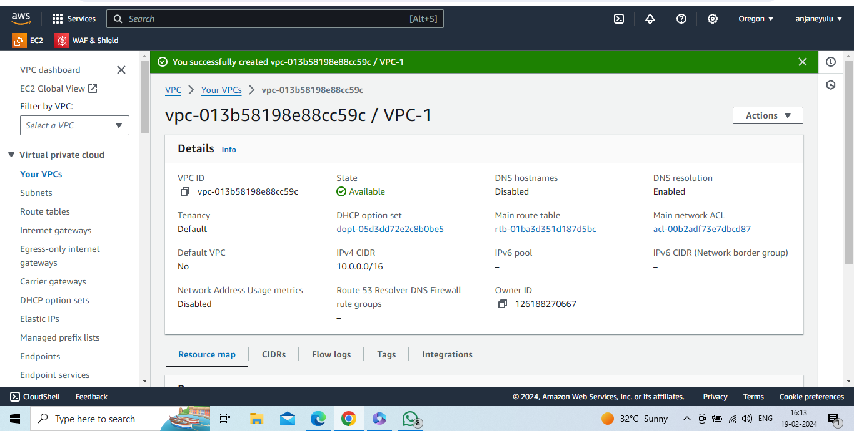

Create subnet-1 in 0regon with IP 10.0.1.0/24 and in creating route table attach VPC-1 to route table1

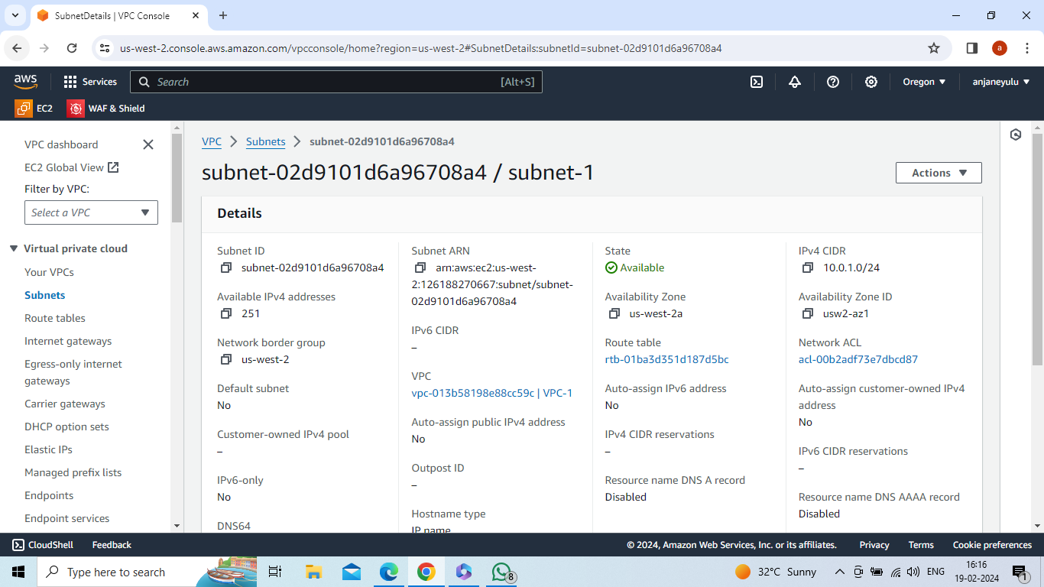

Create route table-1 in aregon and in creating route table attach VPC-1 to route table1

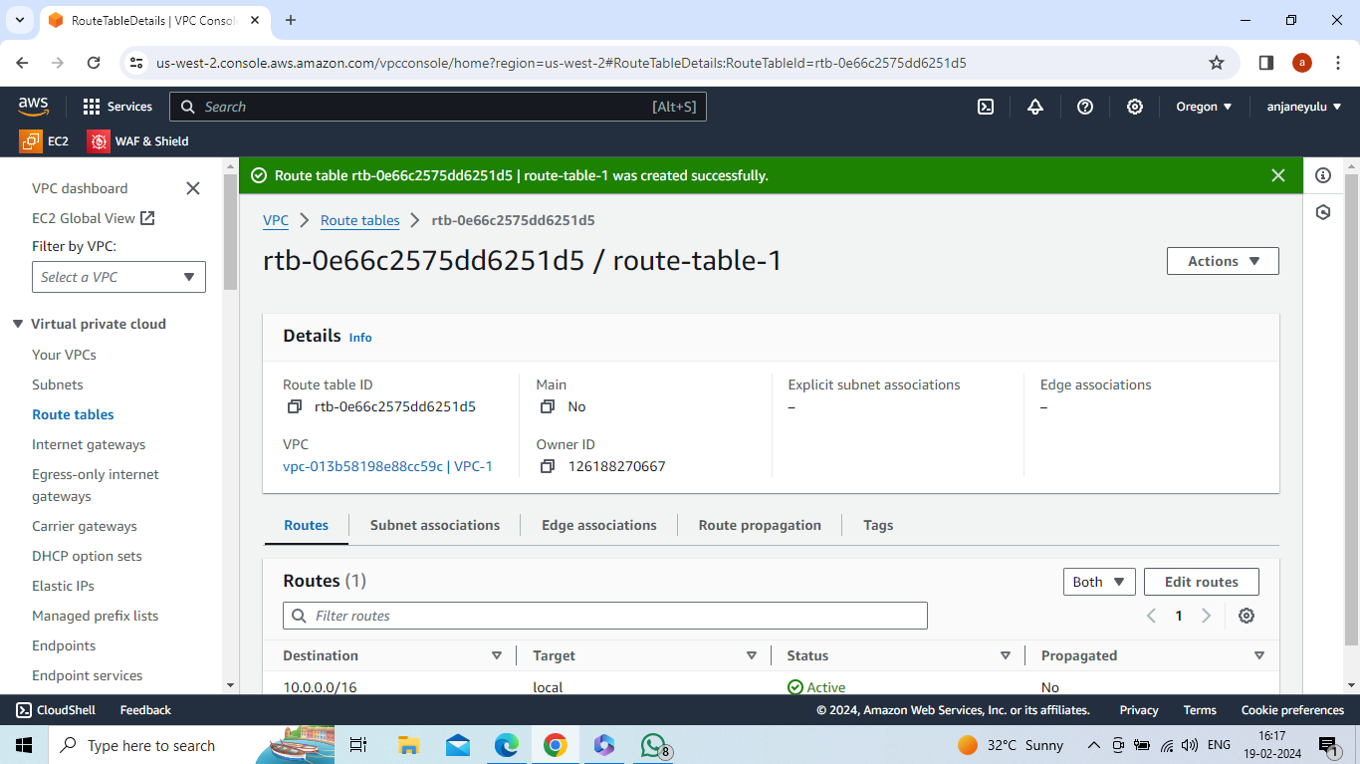

Create internet gateway-1 in oregon

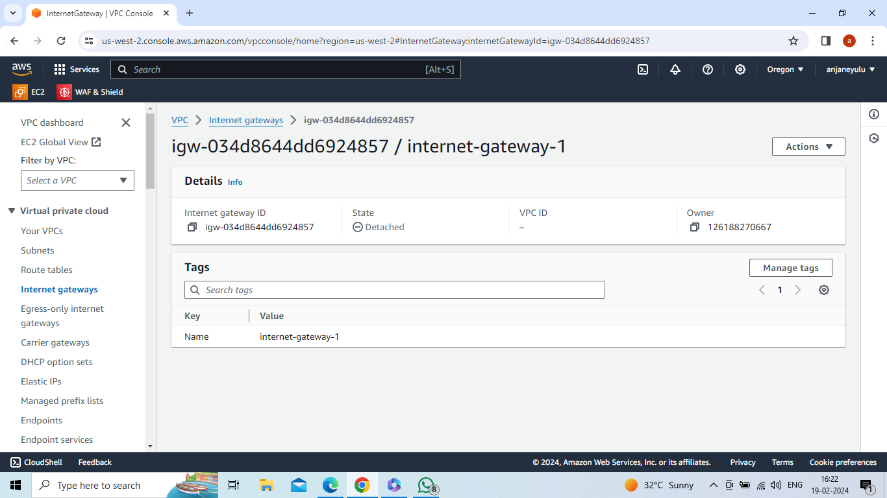

Attach internet gateway-1 with VPC-1

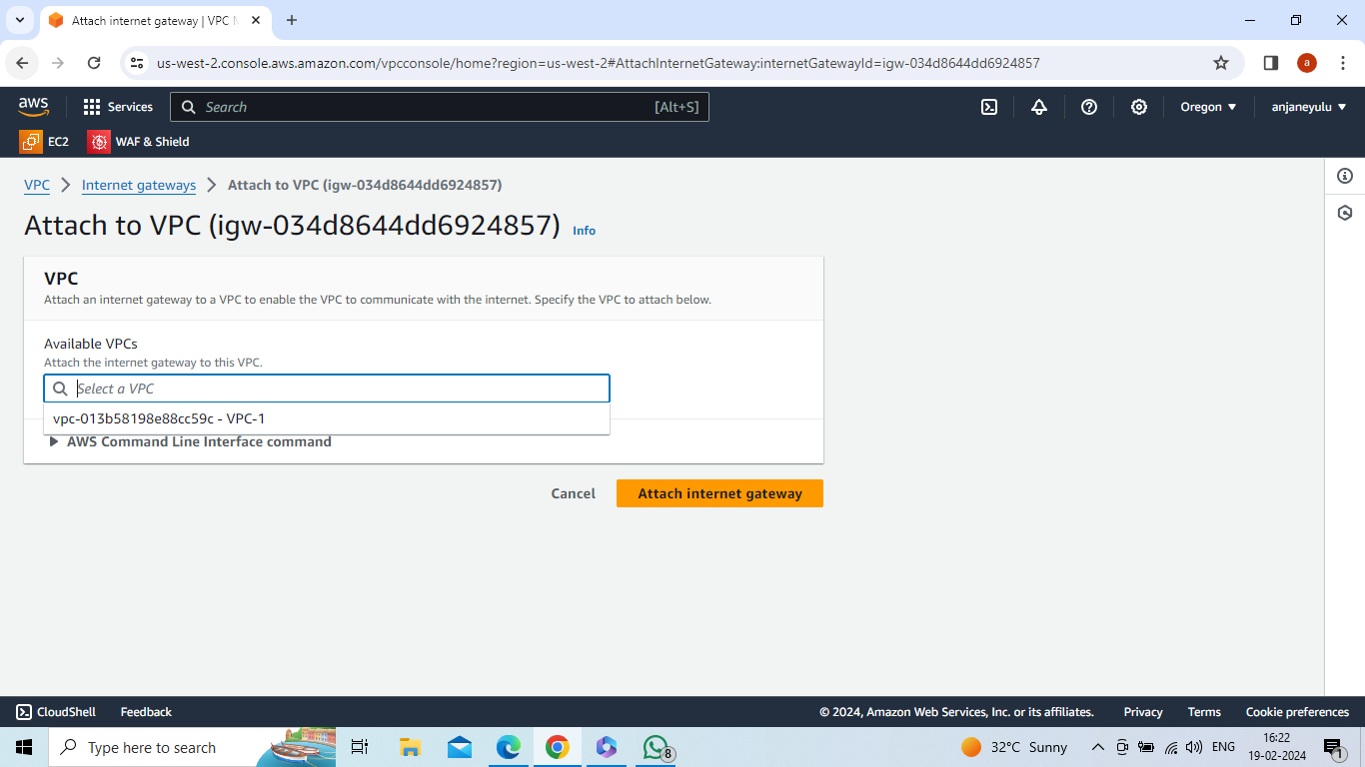

Select Subnet-1 -->actions --> edit routes-->add route-->internet gateway-1 (target) , 0.0.0.0/0(destination) --> save changes

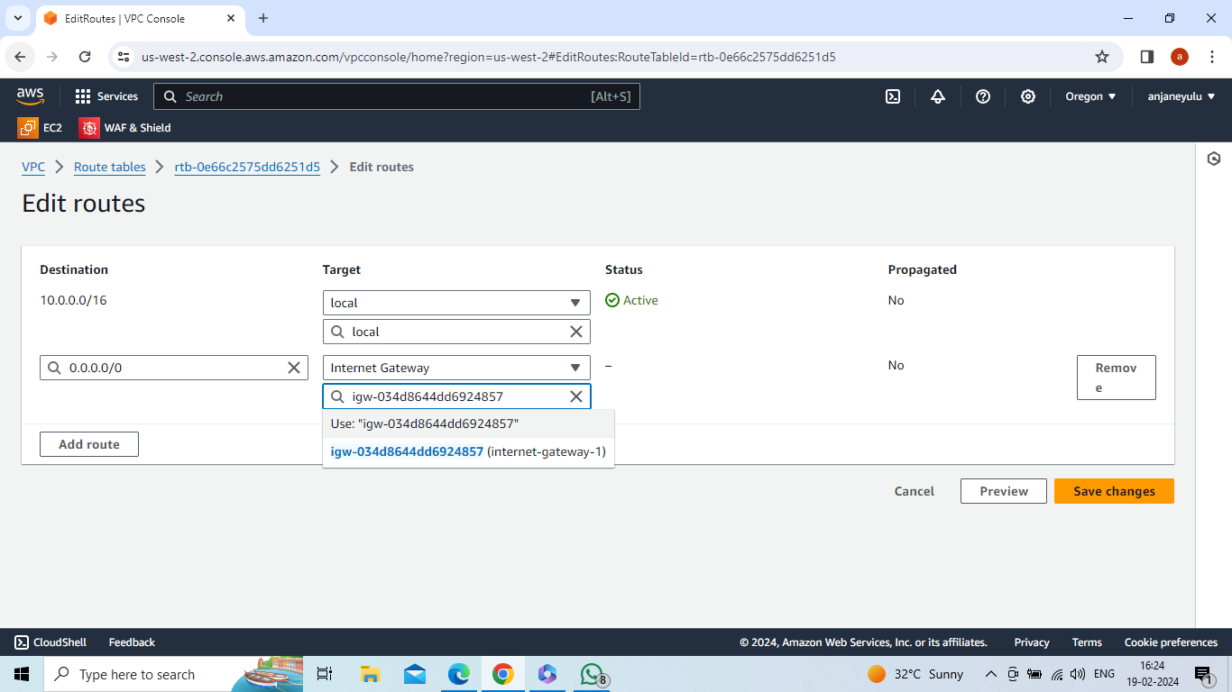

Select Route-table-1-->actions -->edit subnet associations -->select subnet-1 -->save associations

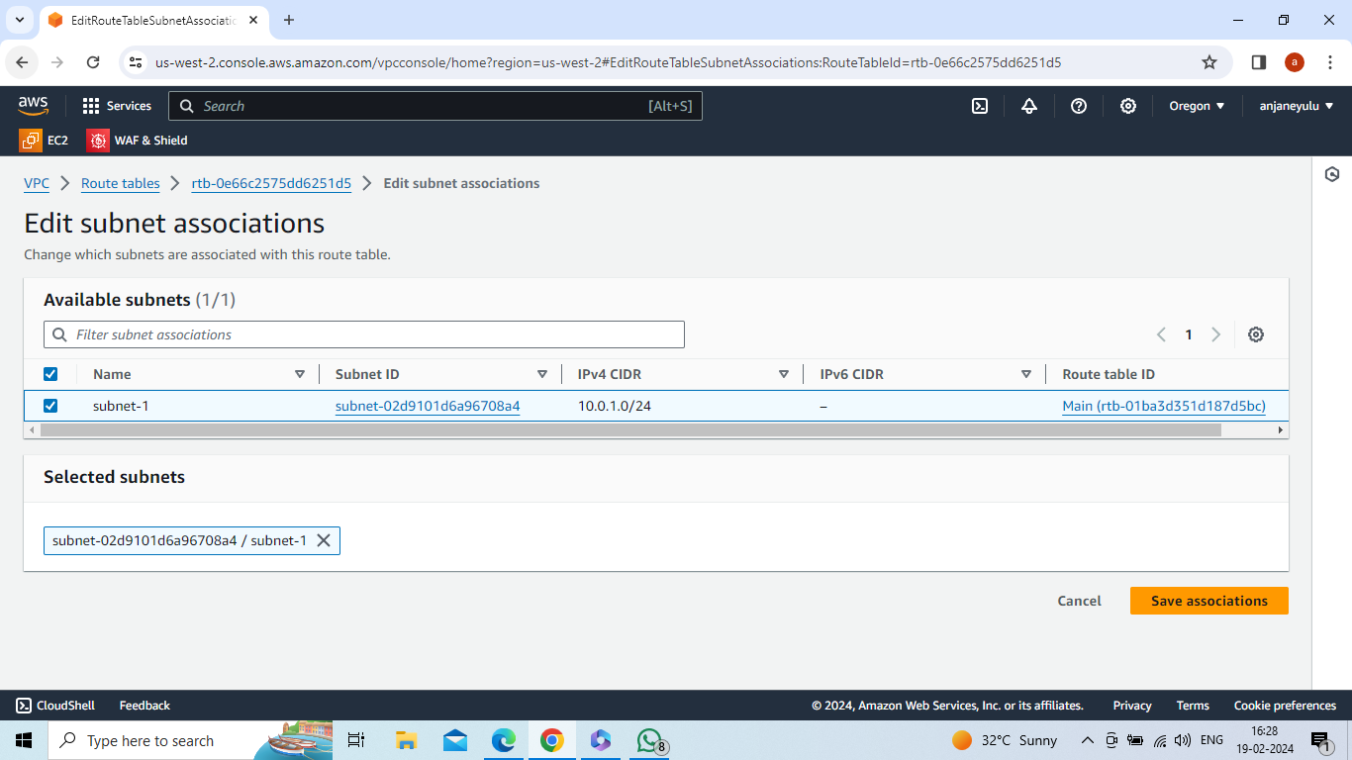

Create VPC-2 in california with IP 11.0.0.0/16

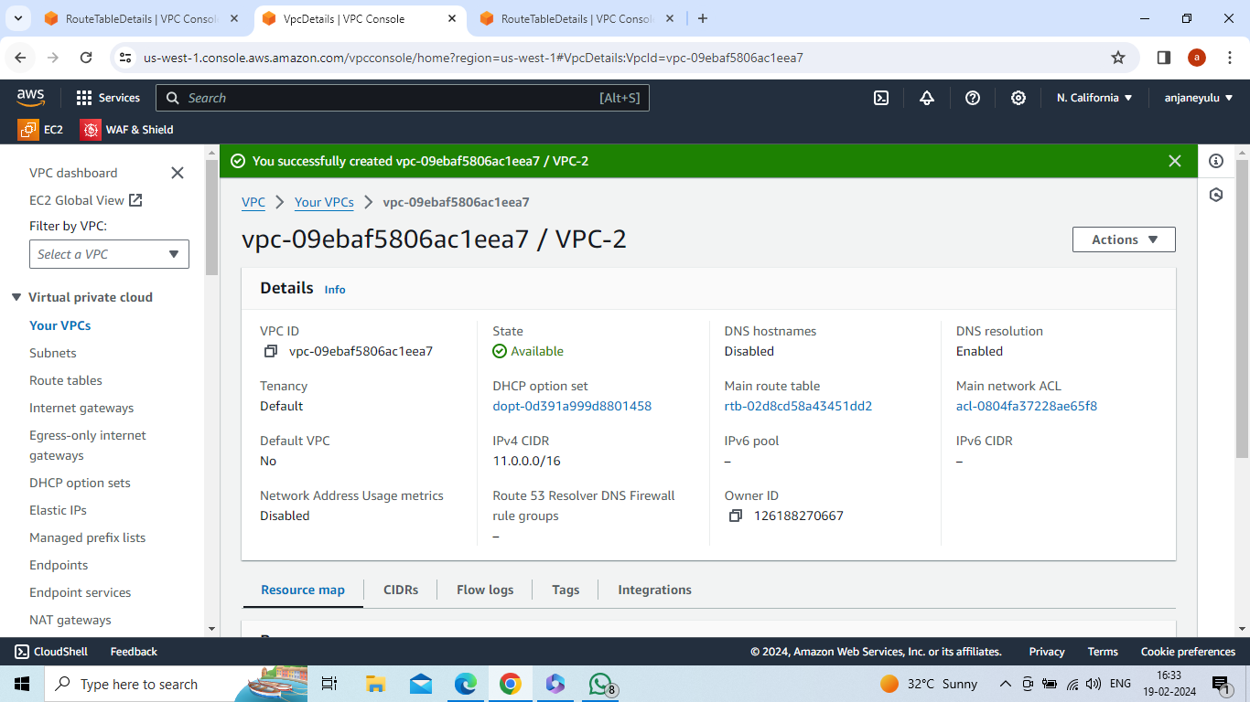

Create subnet-2 in california region with IP 11.0.1.0/24 and in creating route table attach VPC-2 to route table2

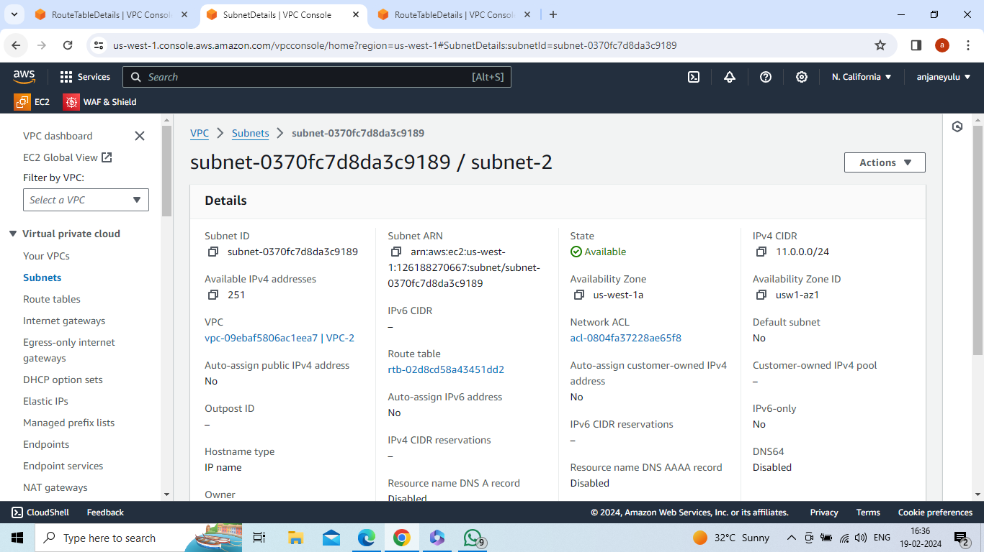

Create route table-2 in california region and in creating route table attach VPC-2 to route table2

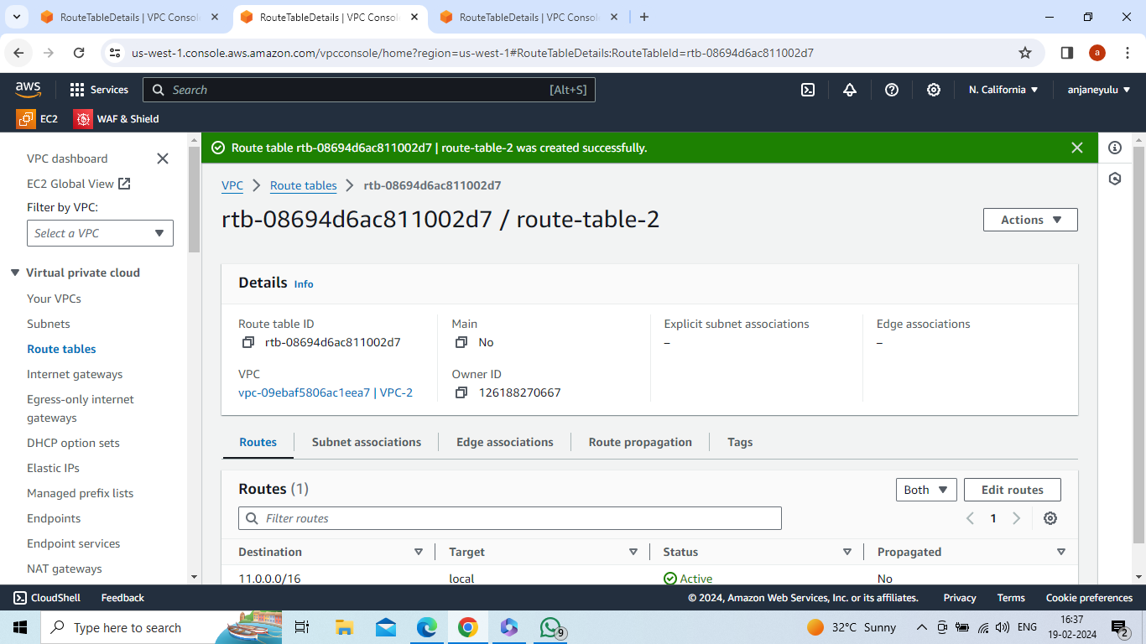

Create internet gateway-2 in california

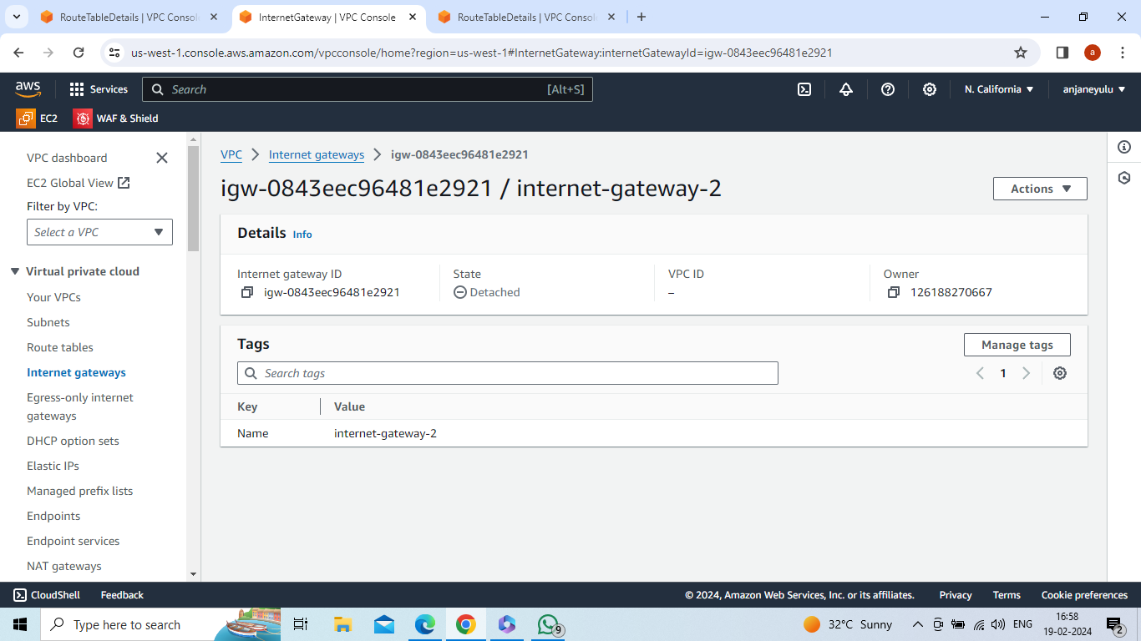

Attach internet gateway-2 with VPC-2

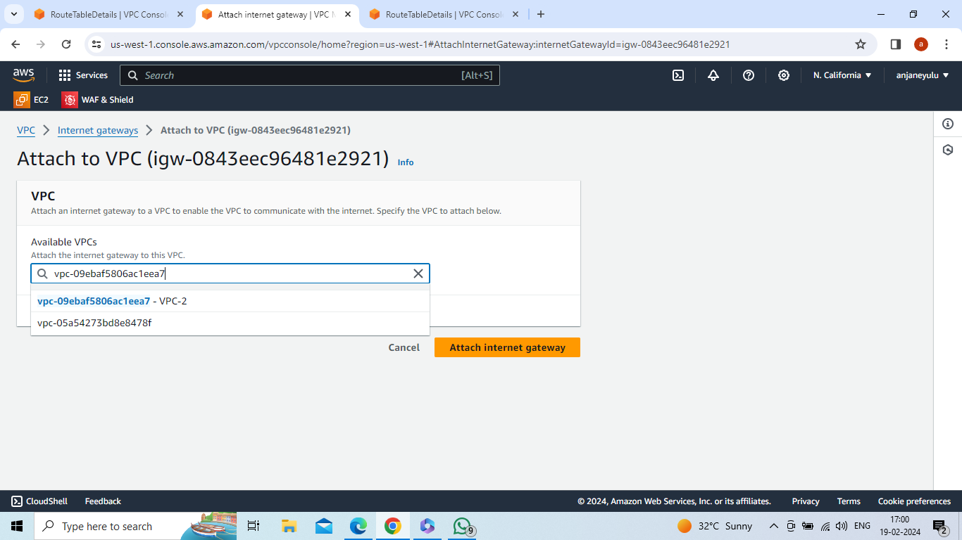

Select Subnet-2 -->actions --> edit routes-->add route-->internet gateway-2 (target) , 0.0.0.0/0(destination) --> save changes

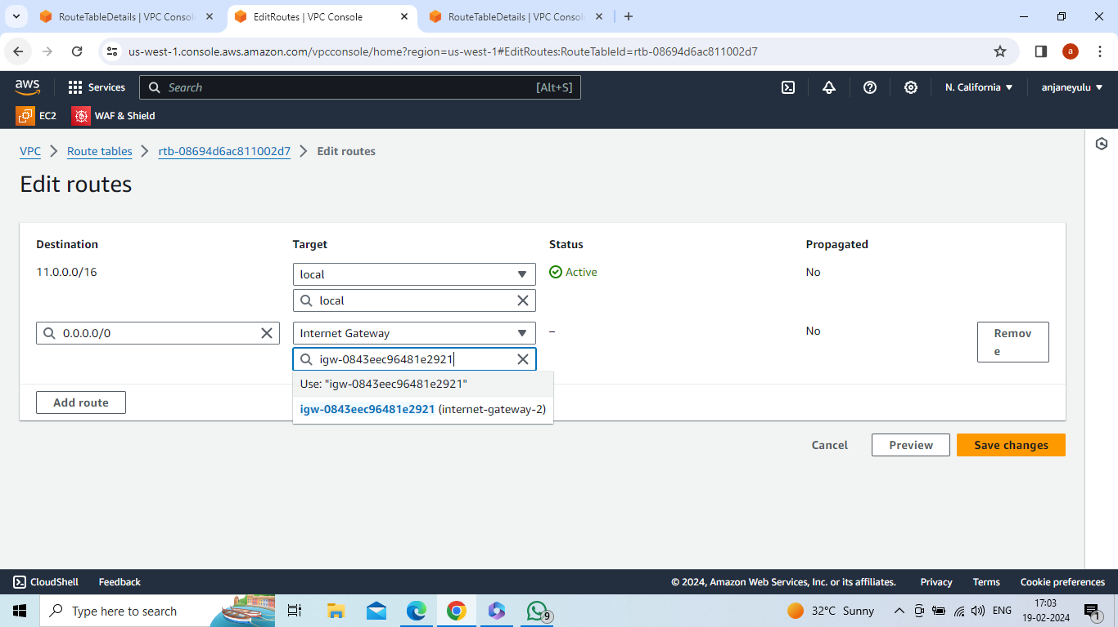

Select Route-table-2-->actions -->edit subnet associations -->select subnet-2 -->save associations

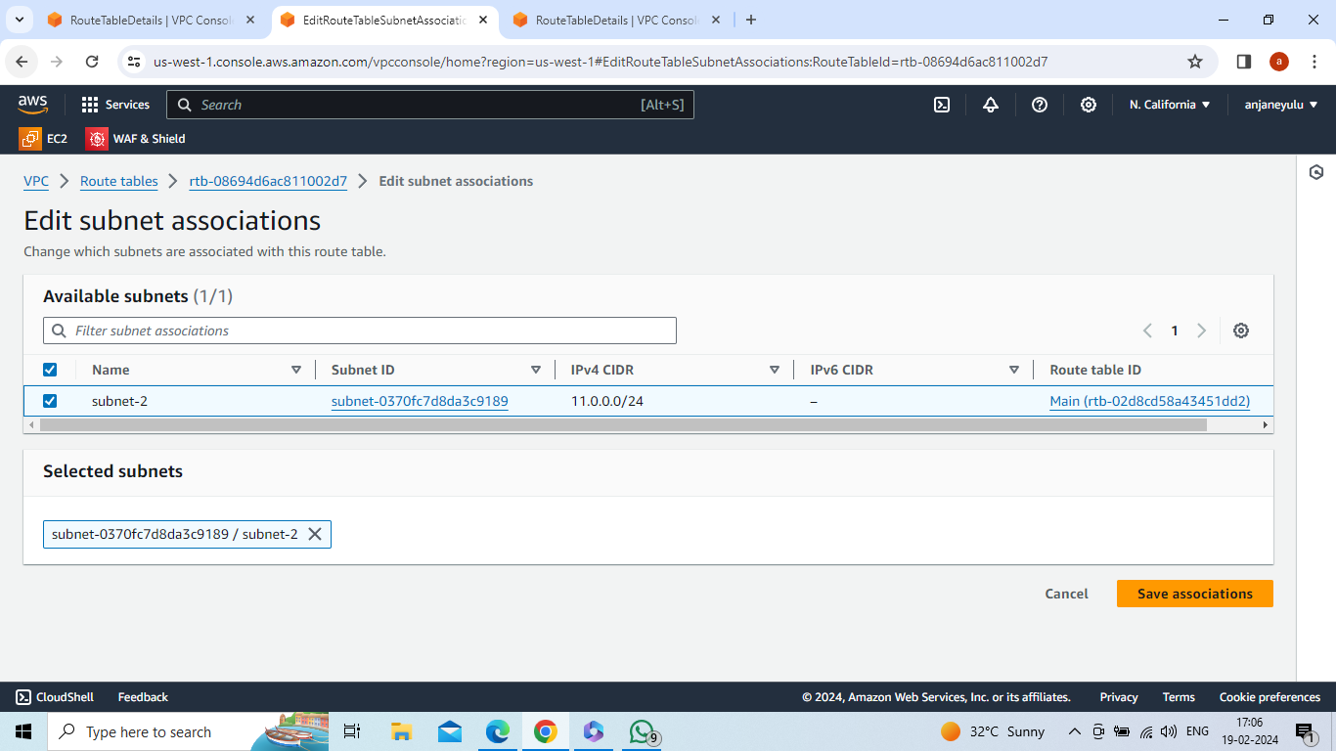

Create VPC-3 in ohio region with IP 12.0.0.0/16

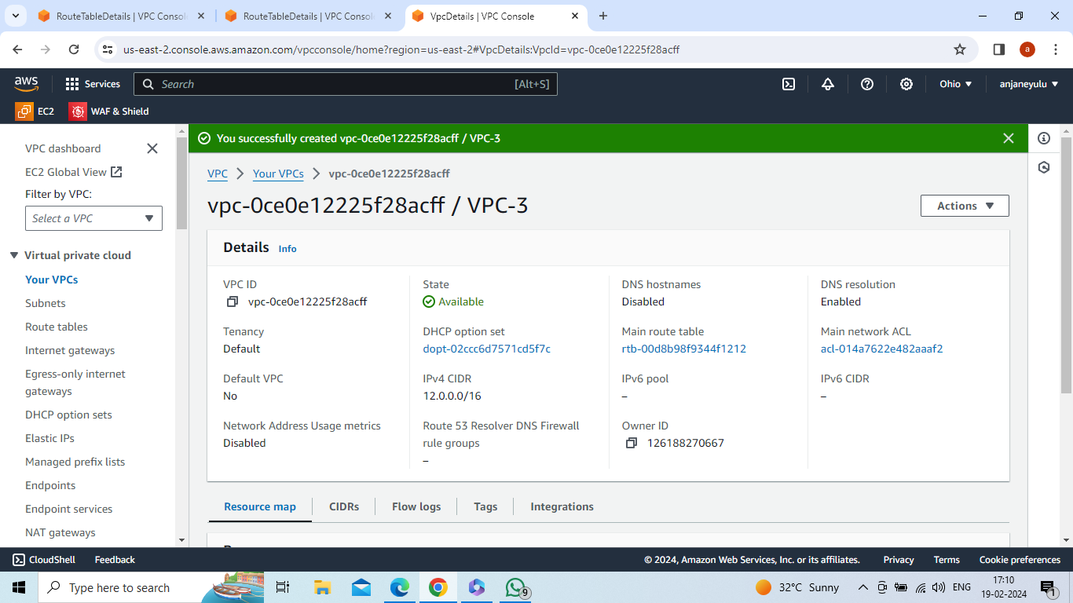

Create subnet-3 in ohio region with IP 12.0.1.0/24 and in creating route table attach VPC-3 to route table3

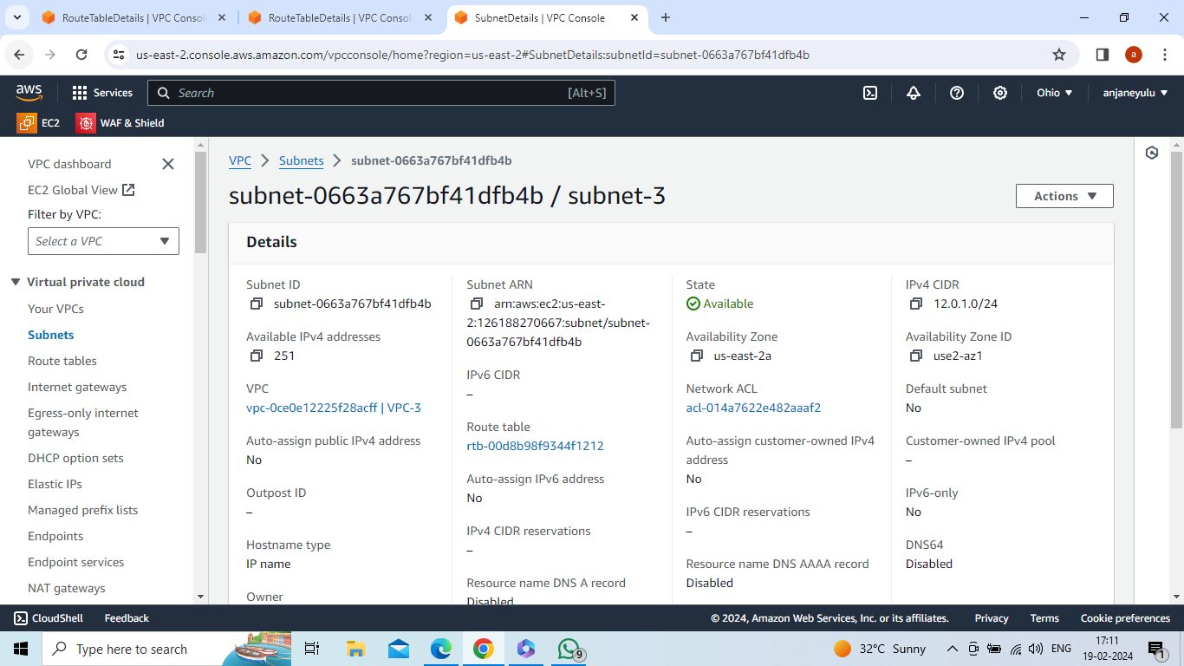

Create route table-3 in california region and in creating route table attach VPC-3 to route table3

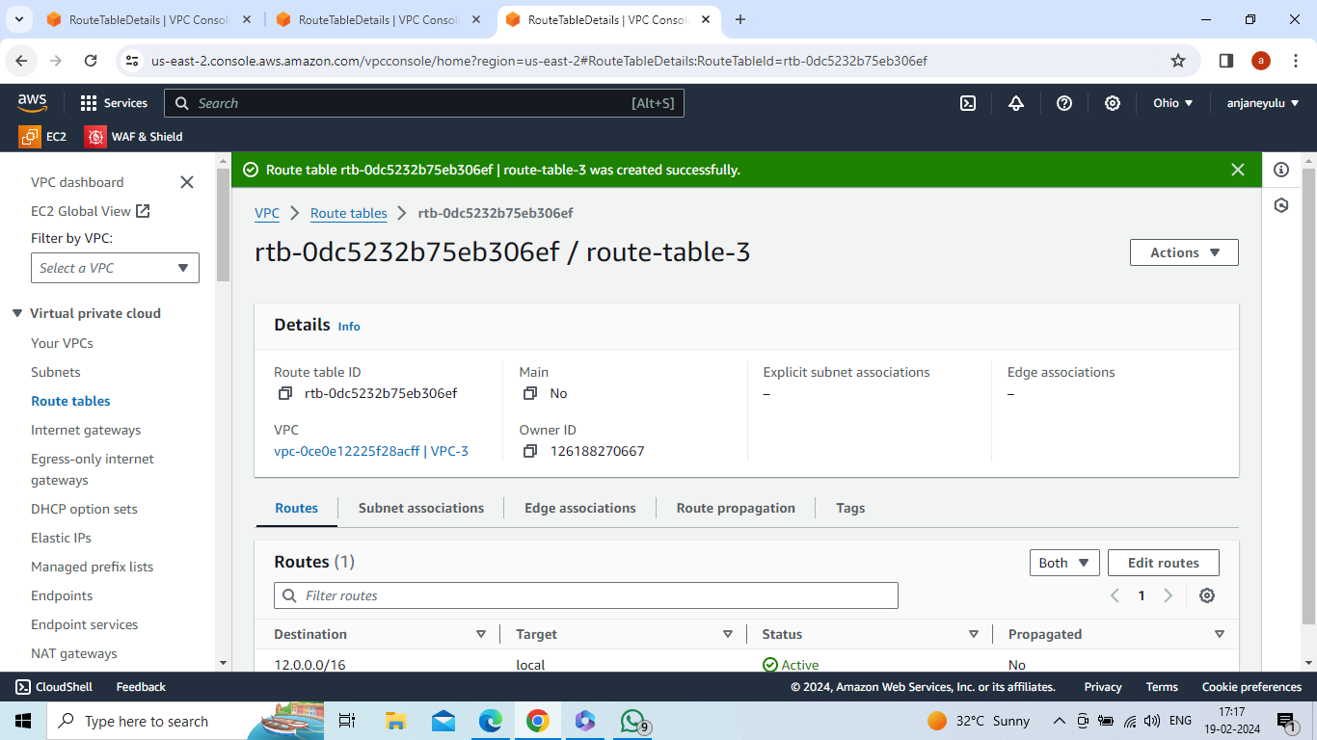

Create internet gateway-3 in ohio region

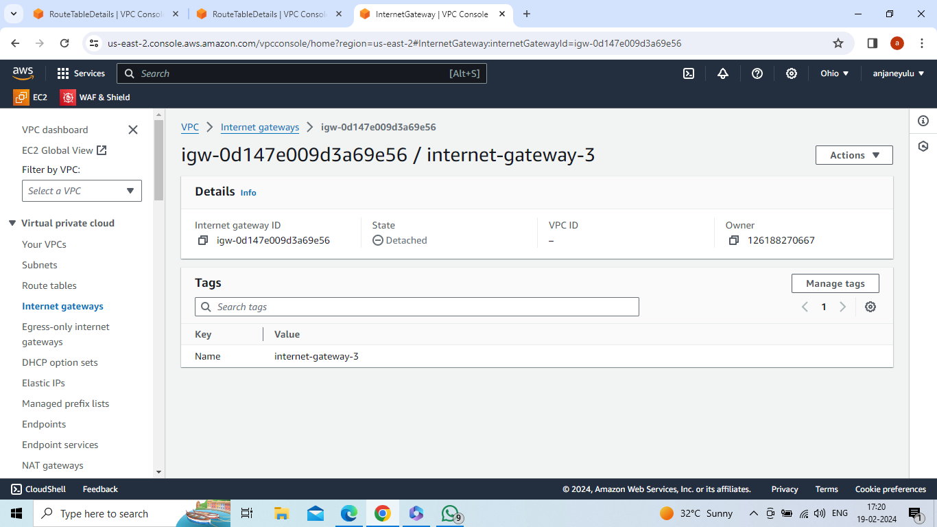

Attach internet gateway-3 with VPC-3

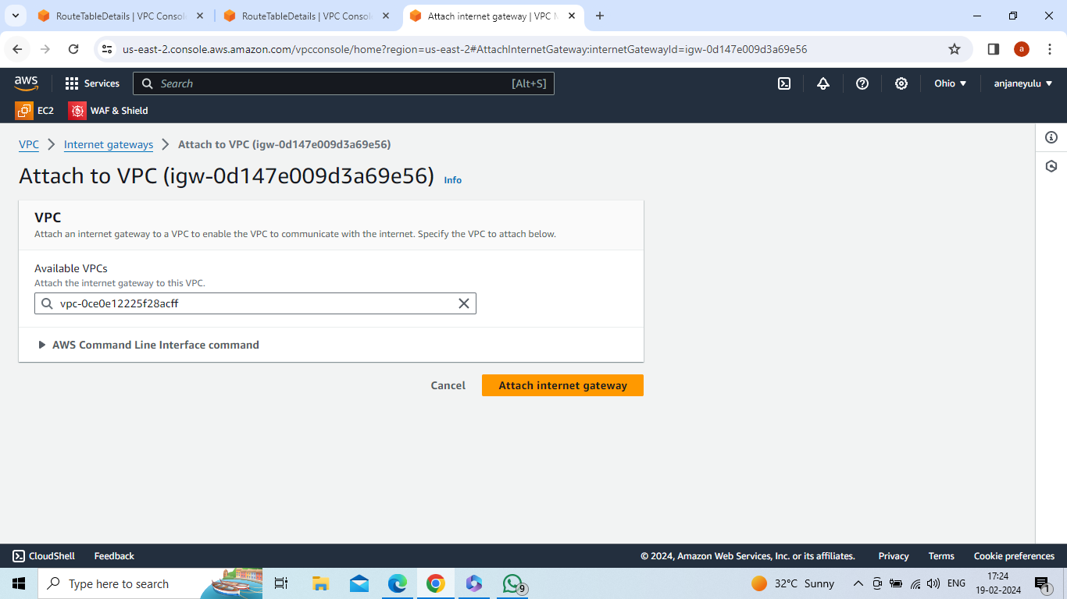

Select Subnet-3 -->actions --> edit routes-->add route-->internet gateway-3 (target) , 0.0.0.0/0(destination) --> save changes

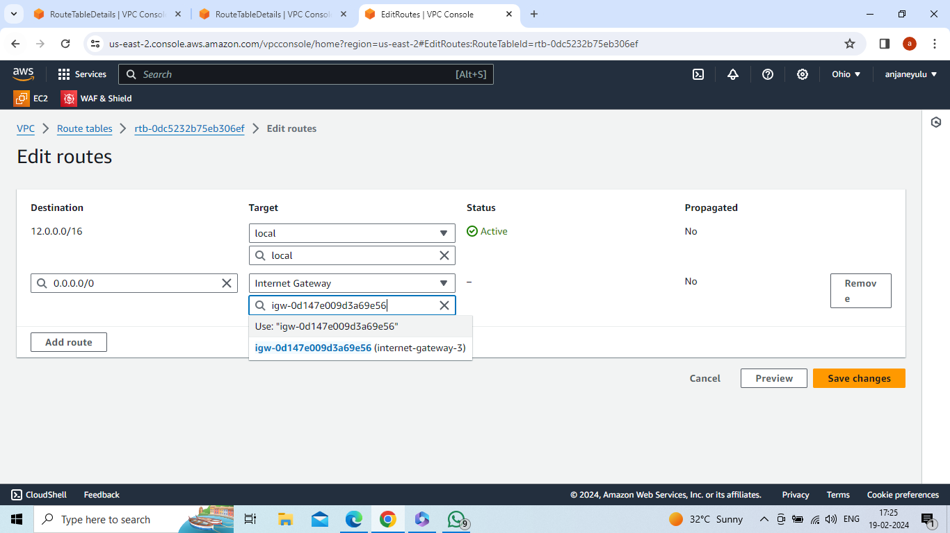

Select Route-table-3-->actions -->edit subnet associations -->select subnet-3 -->save associations

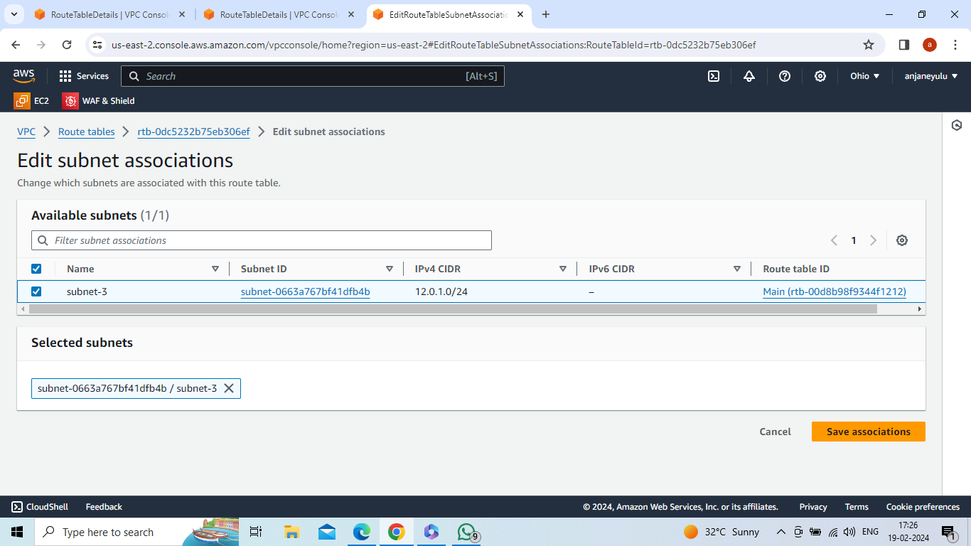

Create transit gateway-1 in oregon region

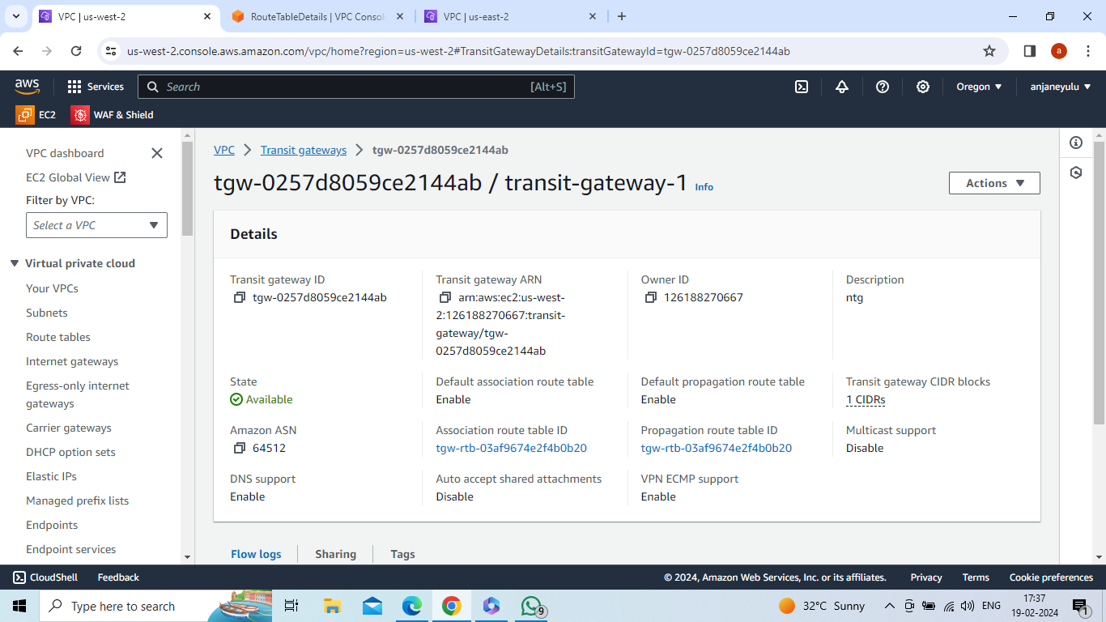

Create transit gateway attechment-1 in oregon region and in creating attachment-1 attach transit-gateway-1 and vpc-1

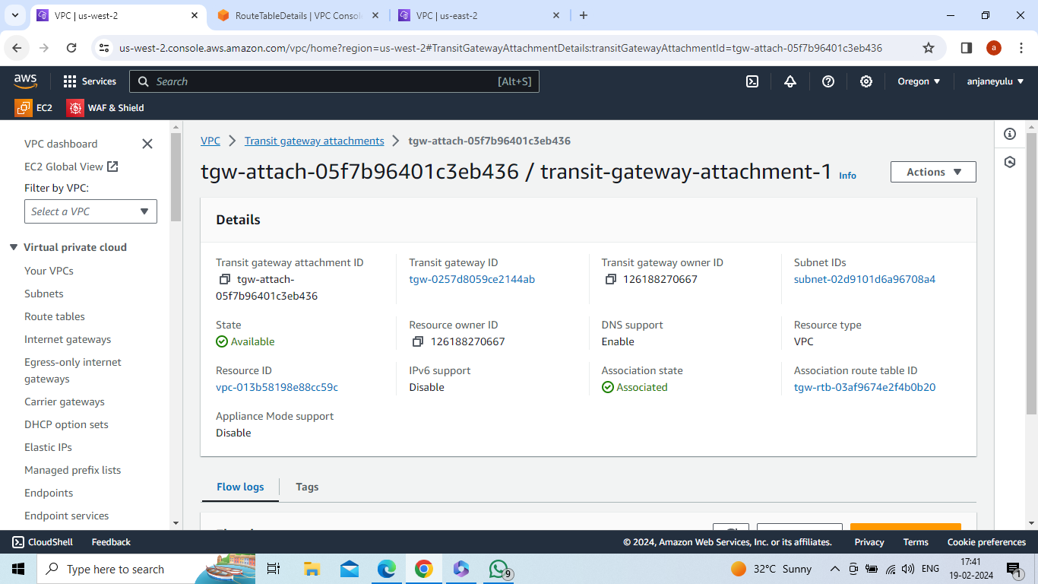

In oregon region -->select route-table-1 -->actions-->edit routes -->add route -->11.0.0.0/16(california IP) in destination , select transit gateway-1 in target --> save changes

In oregon region -->select route-table-1 -->actions-->edit routes -->add route -->12.0.0.0/16(ohio IP) in destination , select transit gateway-1 in target --> save changes

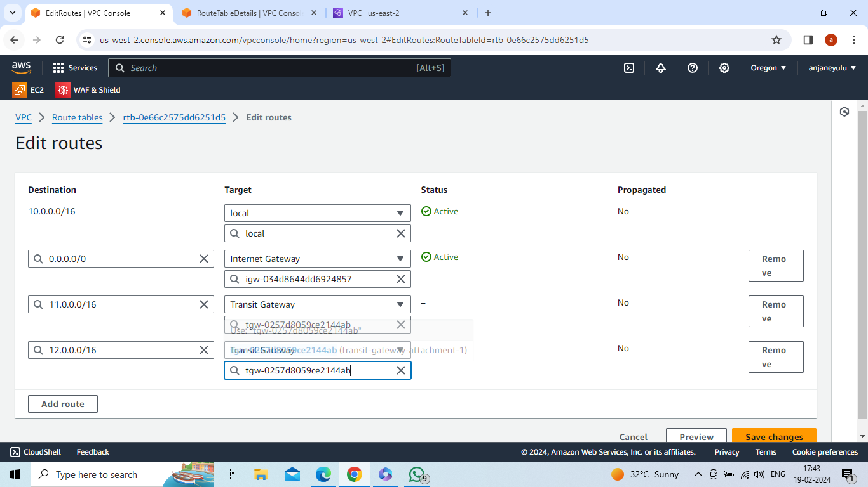

Create transit gateway-2 in california region

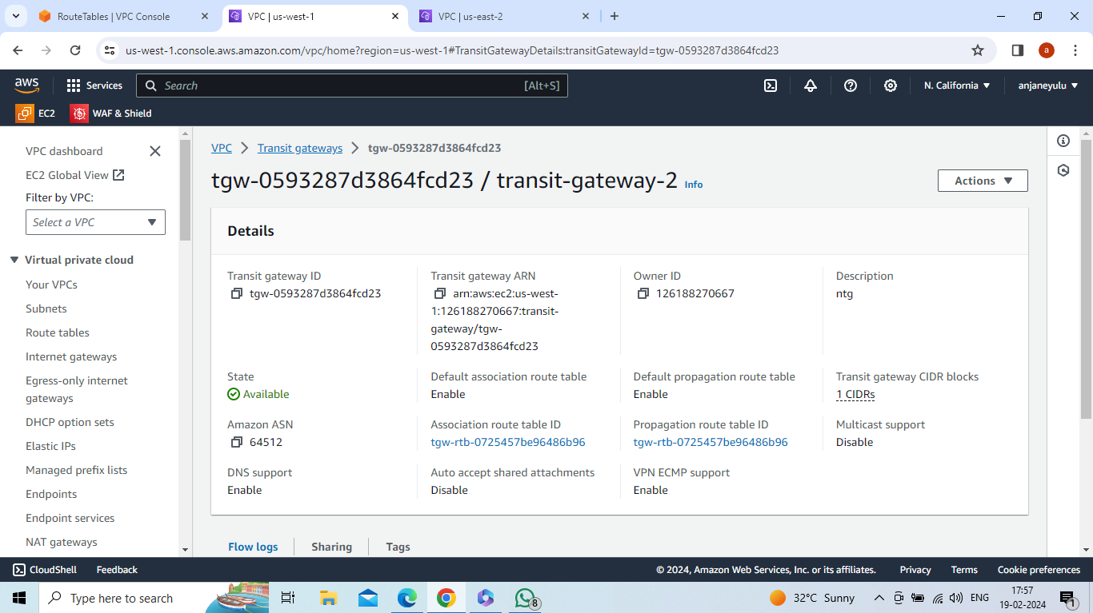

Create transit gateway attechment-2 in oregon region and in creating attachment-2 attach transit-gateway-2 and vpc-2

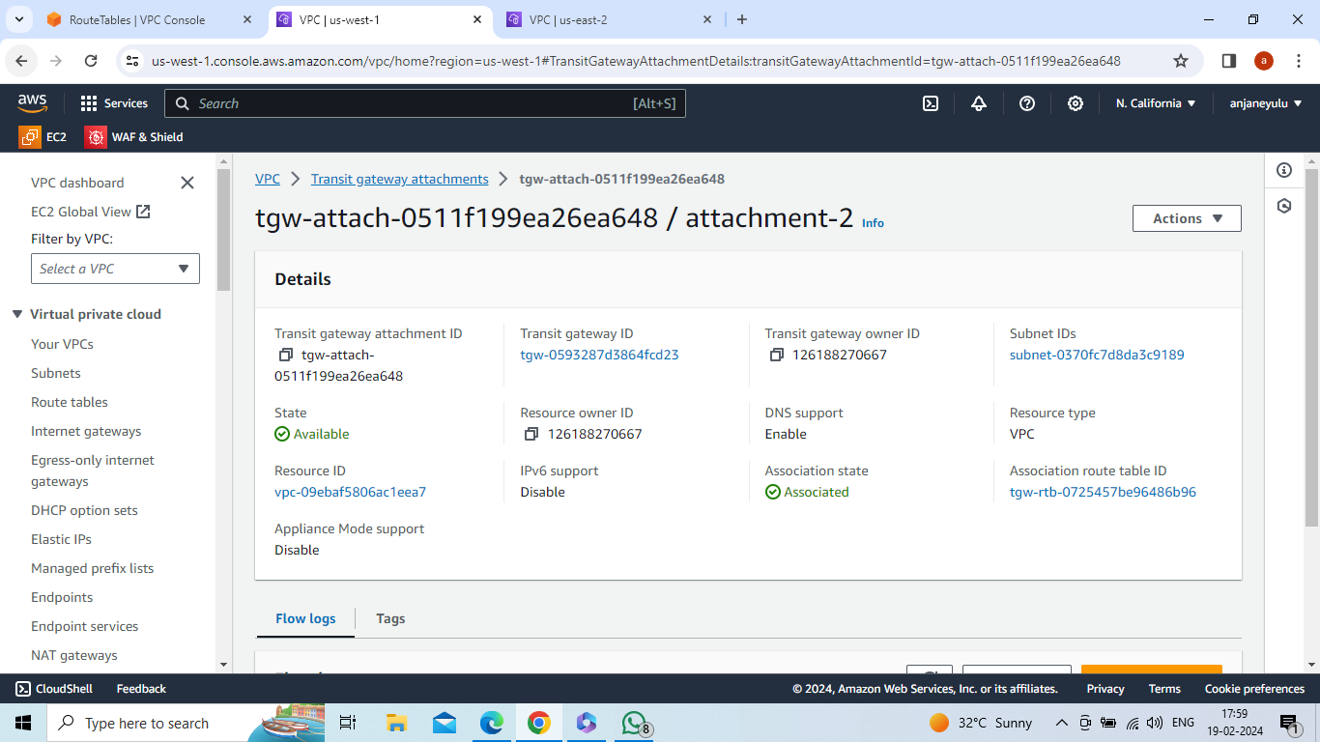

In california region -->select route-table-2 -->actions-->edit routes -->add route -->10.0.0.0/16(oregon IP) in destination , select transit gateway-2 in target --> save changes

In california region -->select route-table-2 -->actions-->edit routes -->add route -->12.0.0.0/16(ohio IP) in destination , select transit gateway-2 in target --> save changes

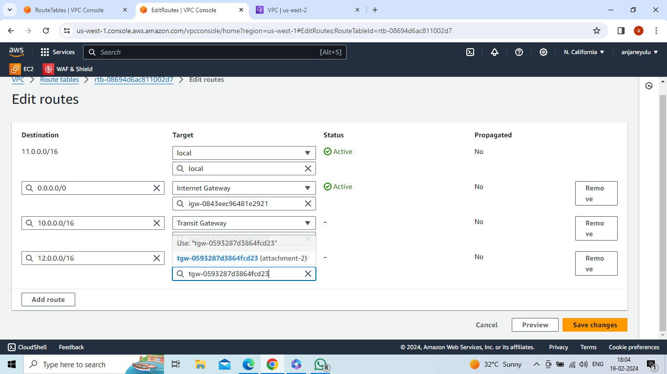

Create transit-gateway-3 in ohio region

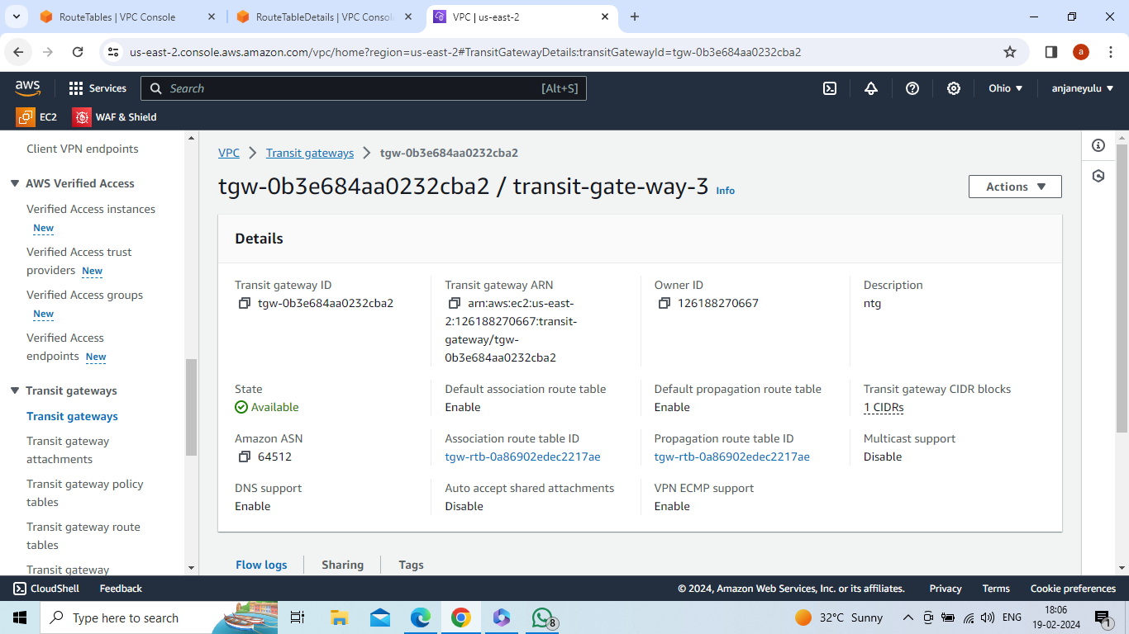

Create transit gateway attachment-3 and in creating attachment-3 attach transit-gateway-3 and vpc-3

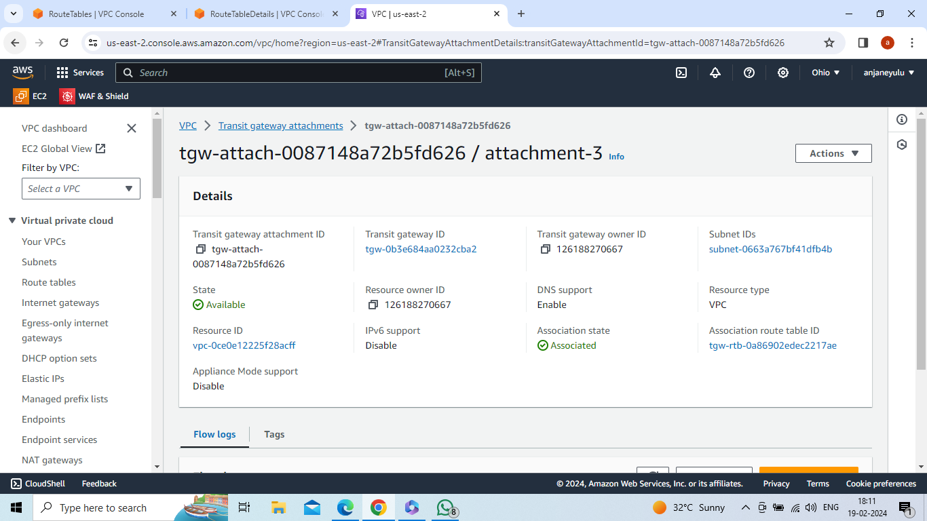

In ohio region -->select route-table-3 -->actions-->edit routes -->add route -->10.0.0.0/16(oregon IP) in destination , select transit gateway-3 in target --> save changes

In ohio region -->select route-table-3 -->actions-->edit routes -->add route -->11.0.0.0/16(california IP) in destination , select transit gateway-3 in target --> save changes

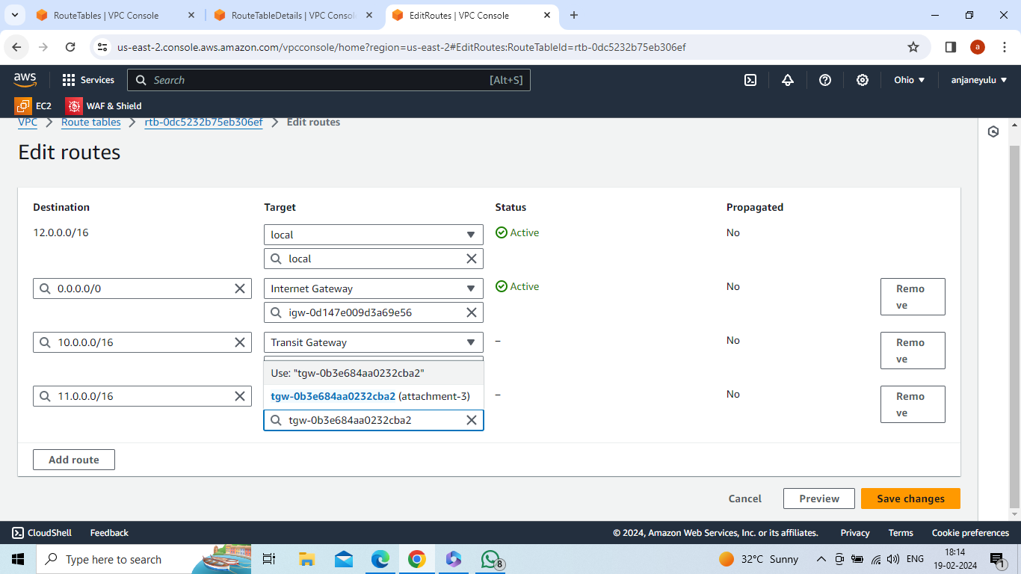

In oregon region -->create transit gateway attachment-2 and in creating attachment-2 attach transit gateway 1 and select attachment type is peering connection and perring connection attachment – select my account ,region –califorina,tansit gateway ID(accepter) of califorina

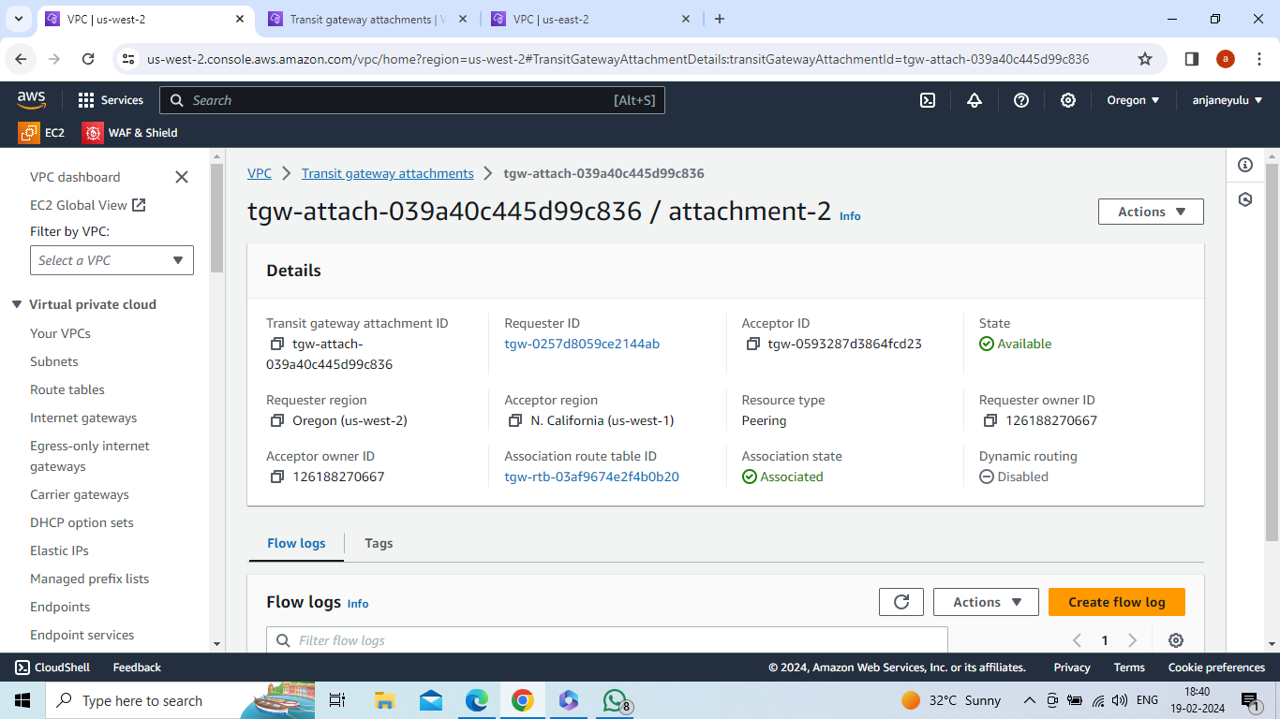

Accept request in califorina region

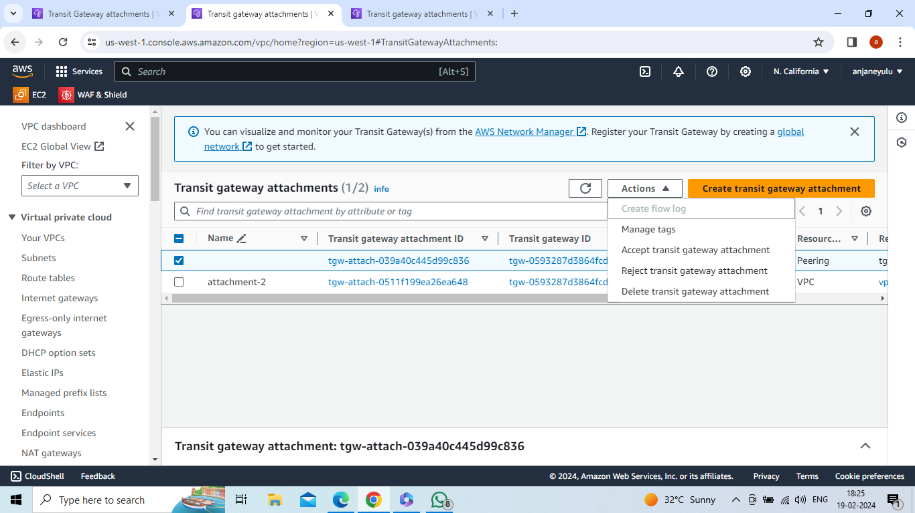

In oregon region -->create transit gateway attachment-3 and in creating attachment-3 attach transit gateway-1 and select attachment type is peering connection and perring connection attachment – select my account ,region –ohio,tansit gateway ID(accepter) of Ohio

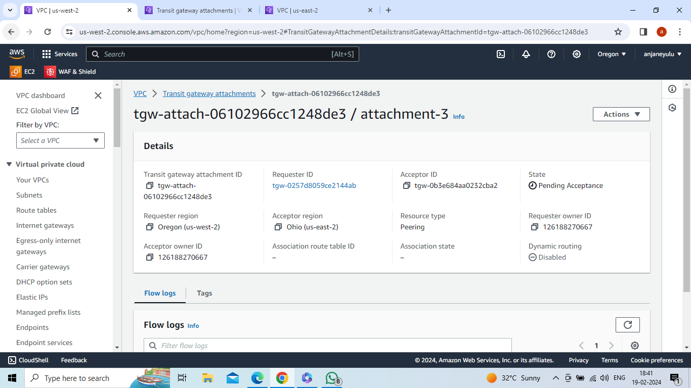

Accept request in ohio region

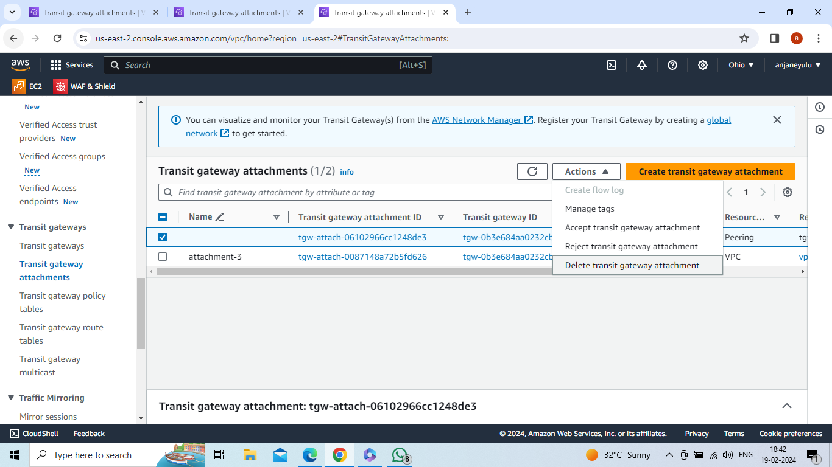

In california region -->create transit gateway attachment-3 and in creating attachment-3 attach transit gateway-2 and select attachment type is peering connection and perring connection attachment – select my account ,region –ohio,tansit gateway ID(accepter) of Ohio

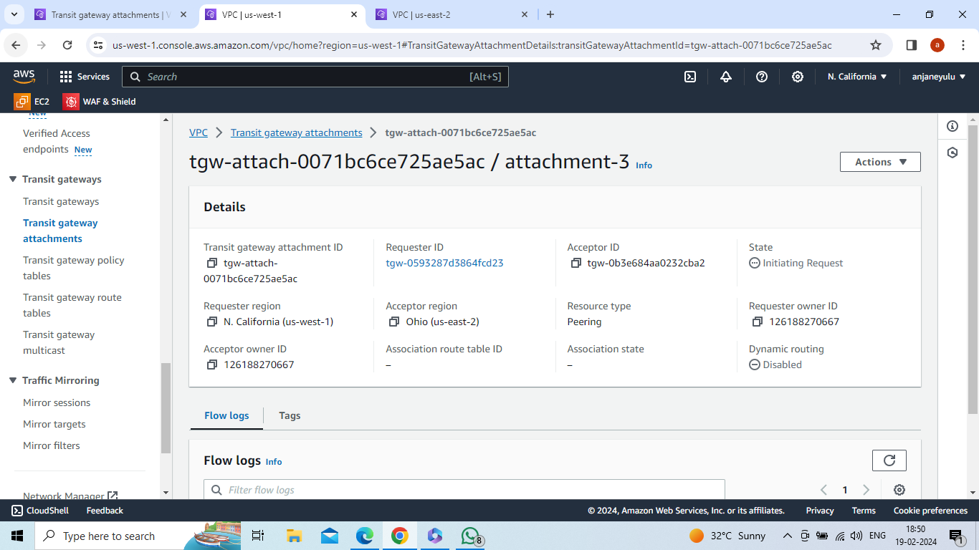

Accept request in ohio region

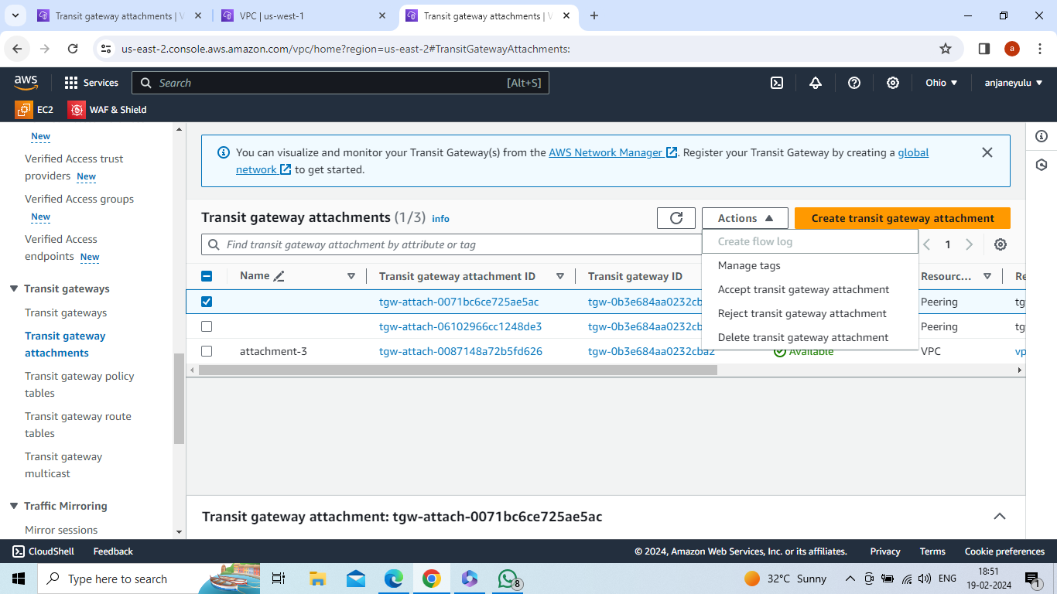

In oregon region --> appear one transit gateway route table -->select that route table --

>actions-->create static route -->CIDR = 11.0.0.0/16 ,attachment type = califorina, transit ID (peering connection)-attchment-2

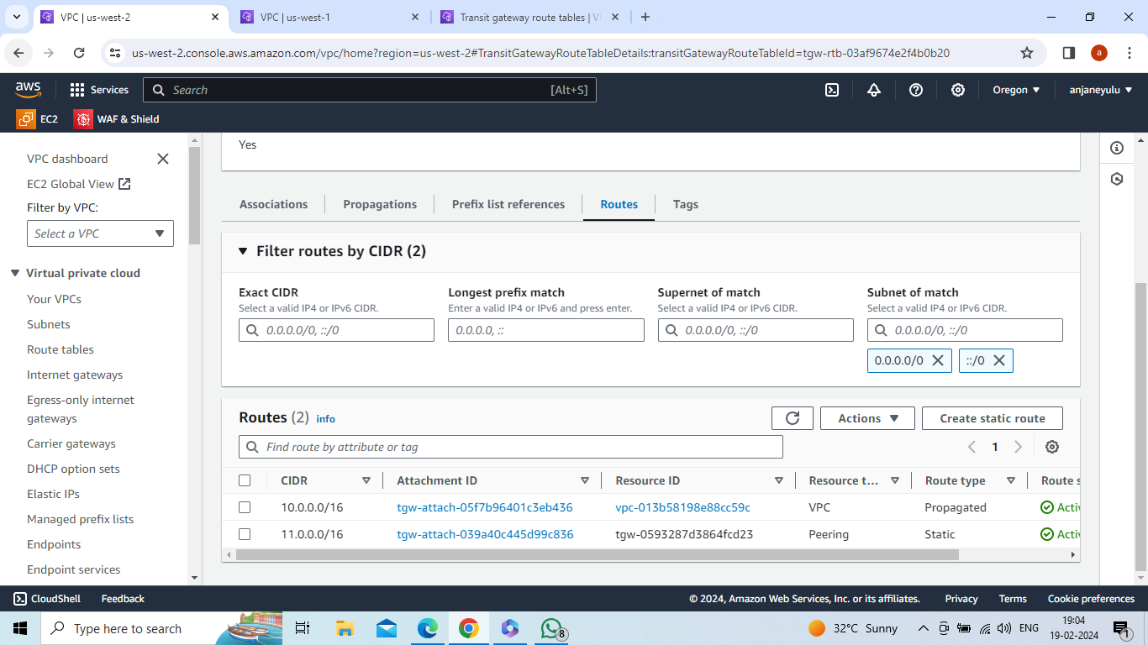

In oregon region --> appear one transit gateway route table -->select that route table --

>actions-->create static route -->CIDR = 12.0.0.0/16 ,attachment type = ohio ,transit ID (peering connection)-attchment-3

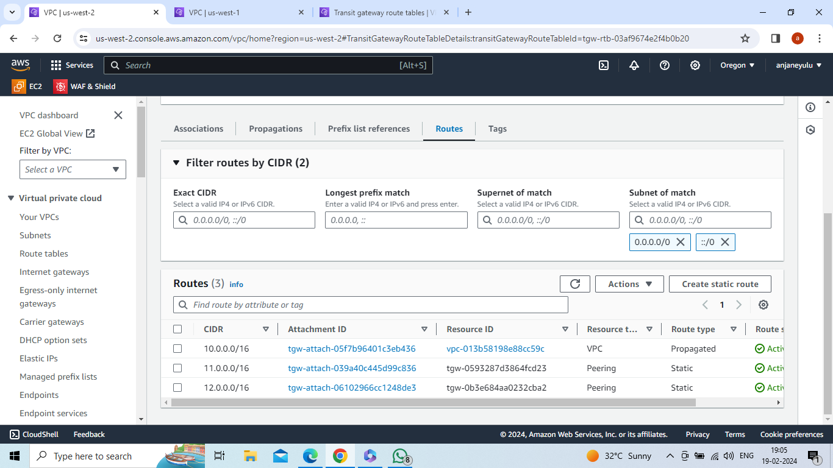

In califorina region --> appear one transit gateway route table -->select that route table --

>actions-->create static route -->CIDR = 10.0.0.0/16 ,attachment type = oregon ,transit ID (peering connection)-

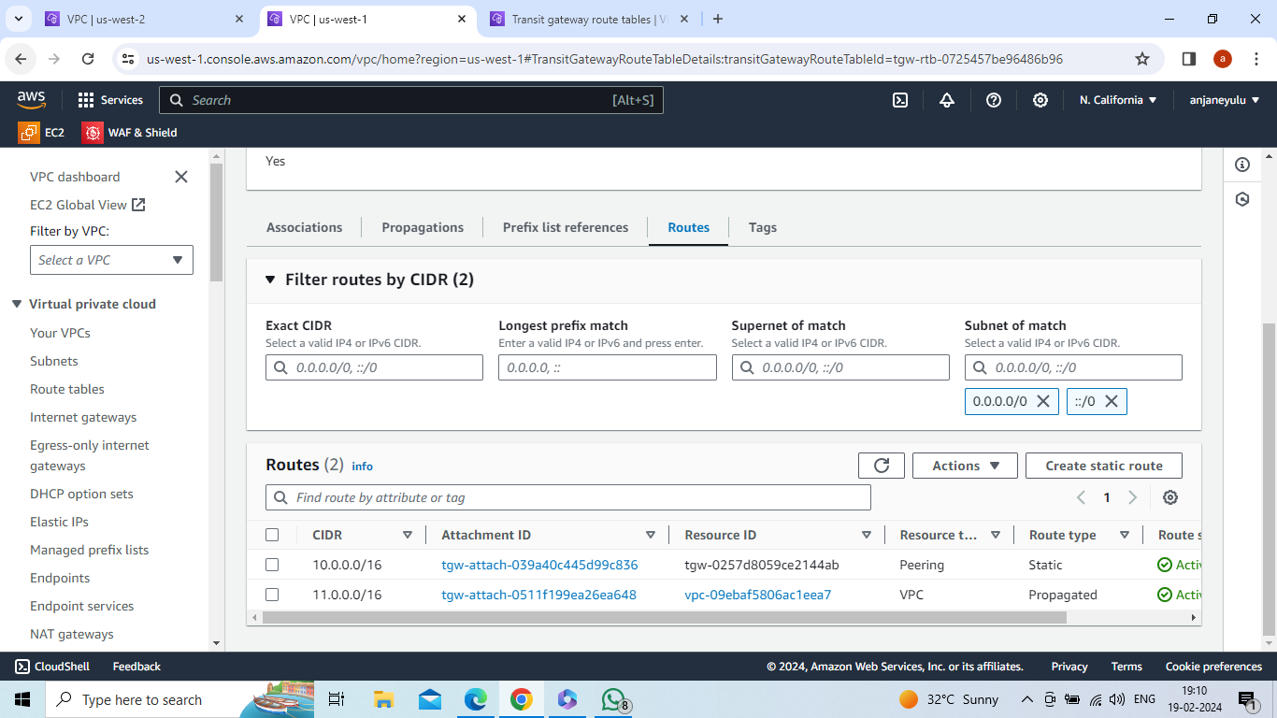

In califorina region --> appear one transit gateway route table -->select that route table --

>actions-->create static route -->CIDR = 12.0.0.0/16 ,attachment type = ohio transit ID (peering connection)-attachment-3

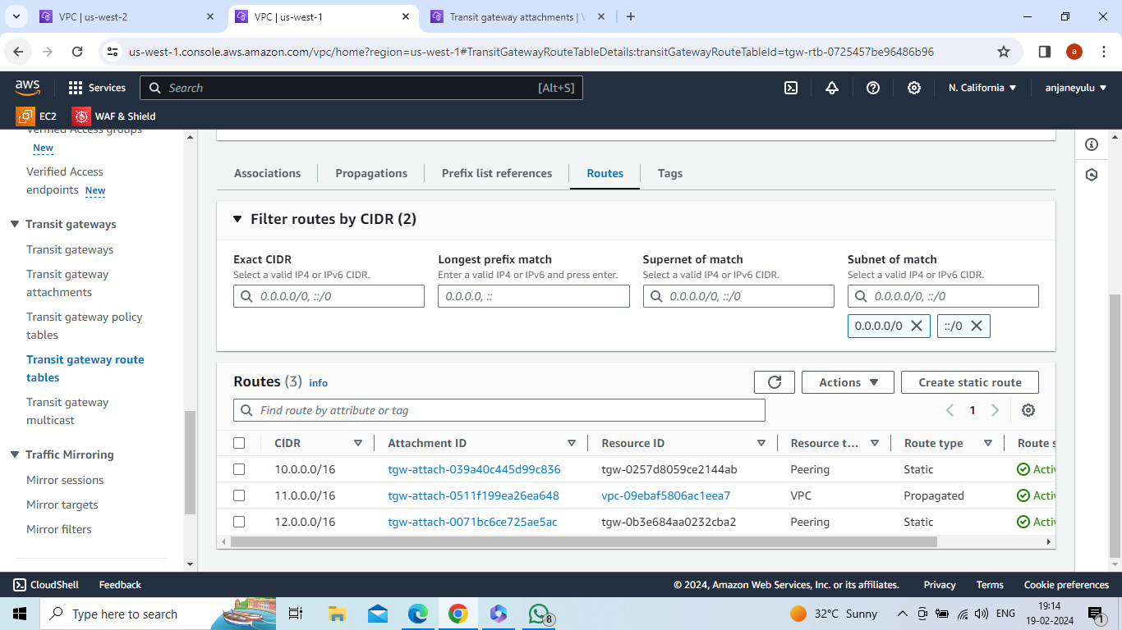

In ohio region --> appear one transit gateway route table -->select that route table --

>actions-->create static route -->CIDR = 10.0.0.0/16 ,attachment type = oregon transit ID (peering connection)-

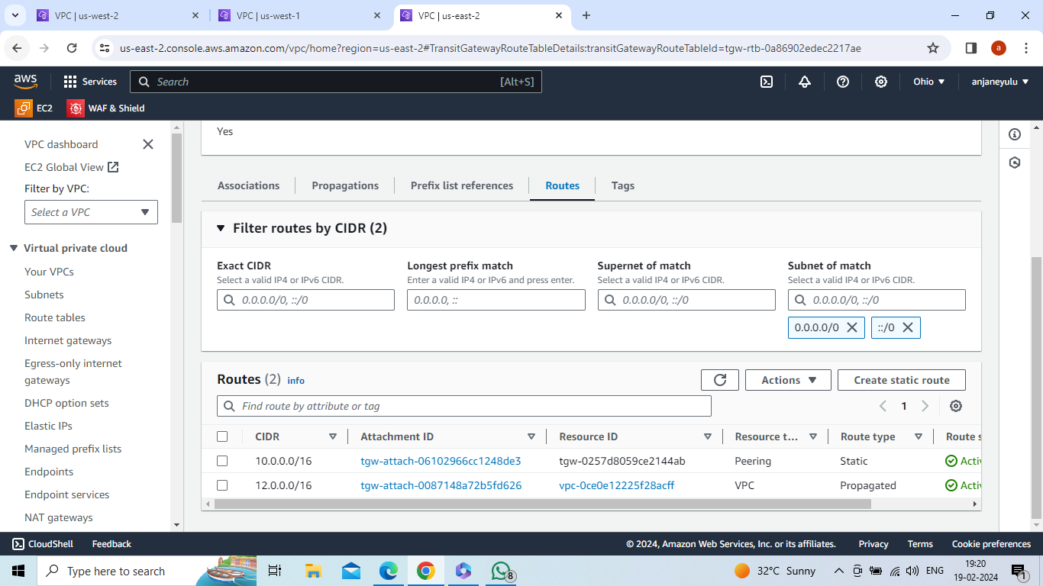

In ohio region --> appear one transit gateway route table -->select that route table --

>actions-->create static route -->CIDR = 11.0.0.0/16 ,attachment type = california transit ID (peering connection)-

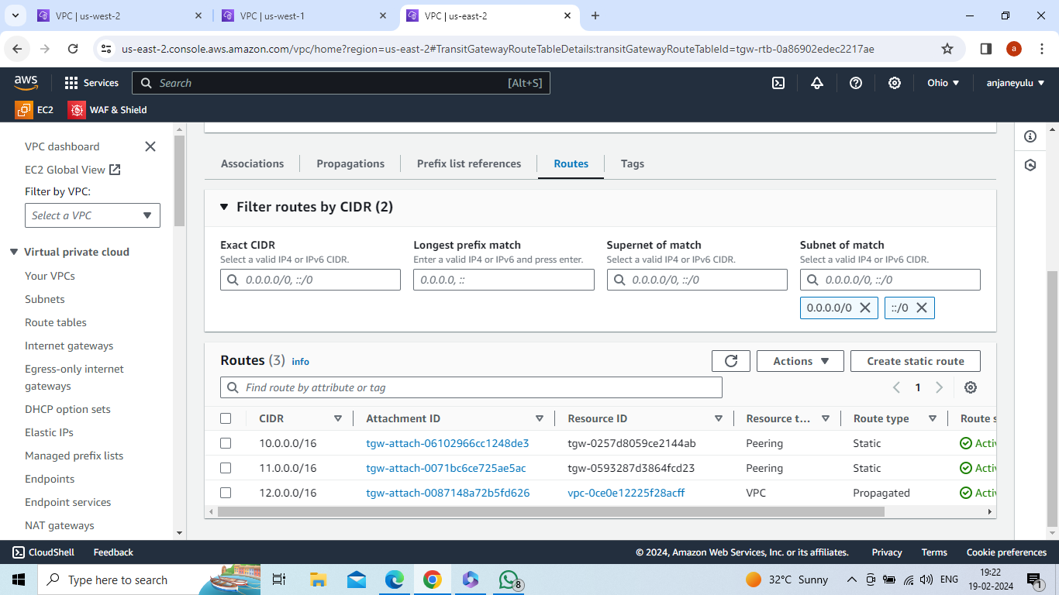

In oregon region -->create and launch instance : server1-->connect to server

Select : Server1 -->security group -->actions-->edit inbound rules -->add rule-->custom tcp,port range: 80

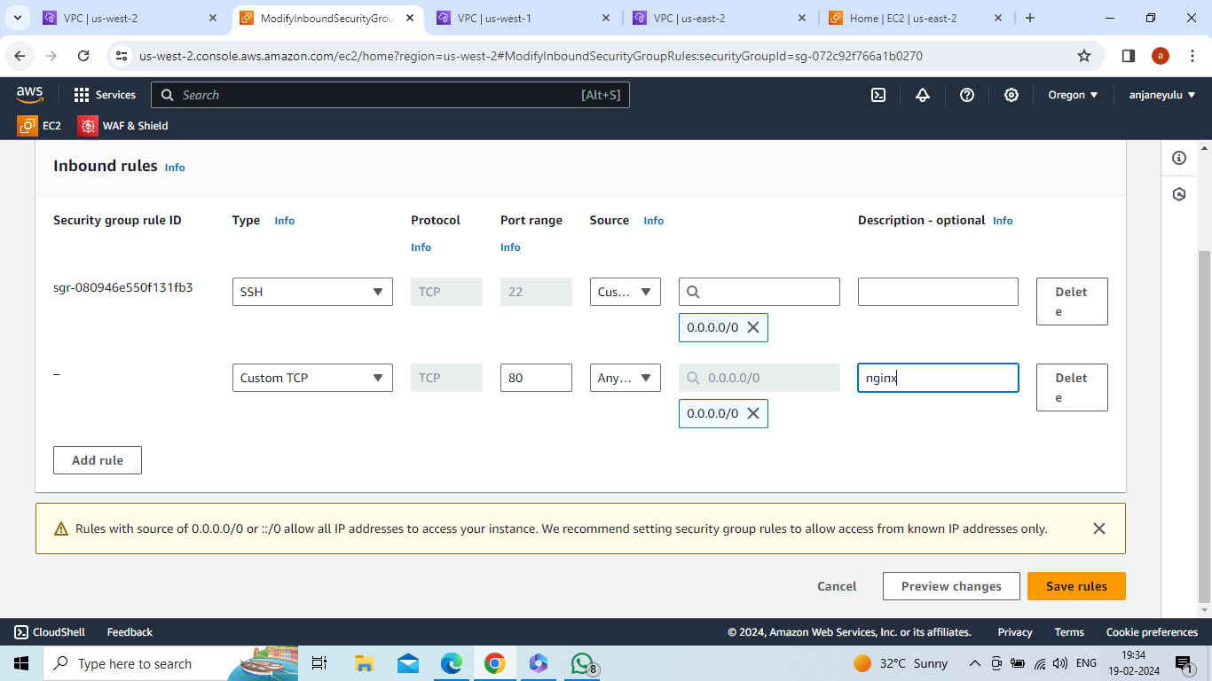

Connect to server in aws(oregon)

Sudo –i(convert to root user)

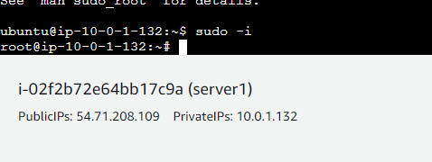

Apt install nginx –y

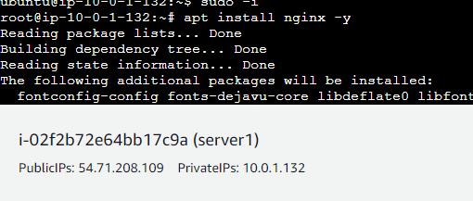

Cd /var/www/html

Ls

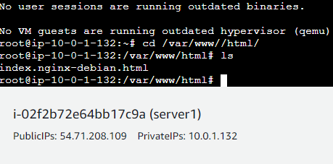

Rm index.nginx-debian.html

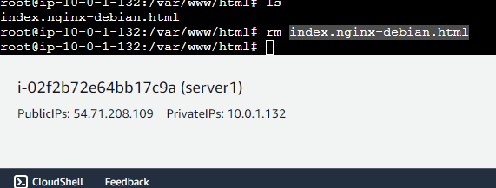

Vi index.html-->this is transit gateway(insert data in file)-->save and quit (wq)

Systemctl restart nginx

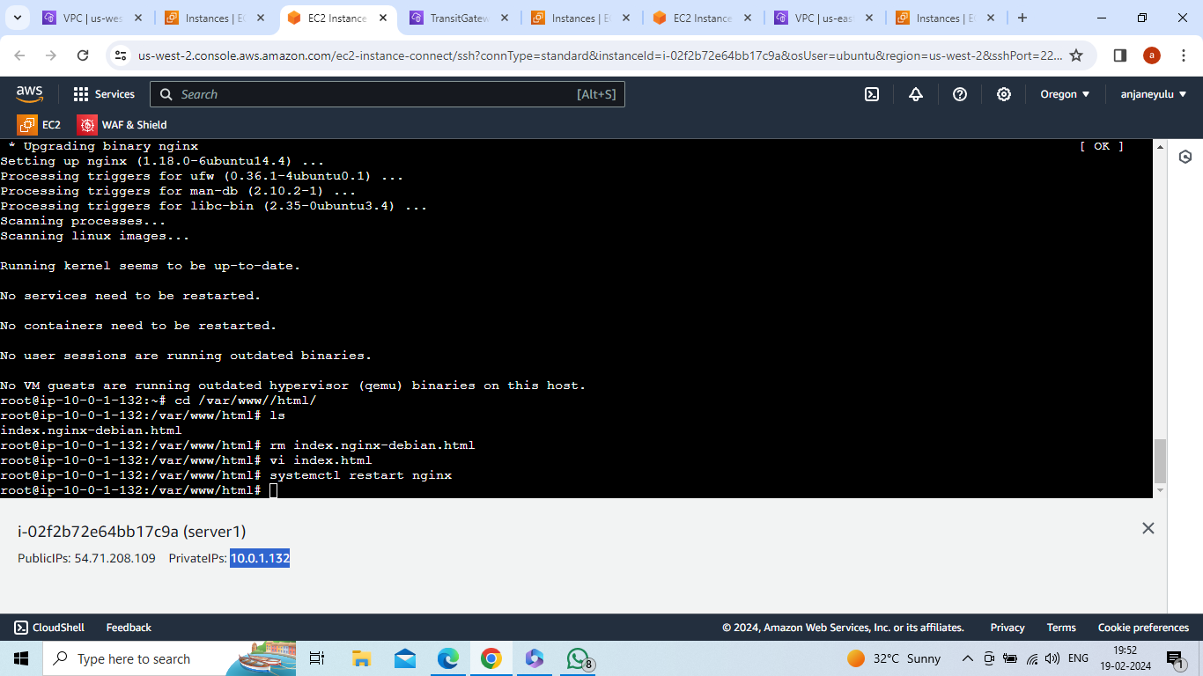

In california region -->create and launch instance : server2-->connect to server

Select : Server2 -->security group -->actions-->edit inbound rules -->add rule-->custom tcp,port range: 80

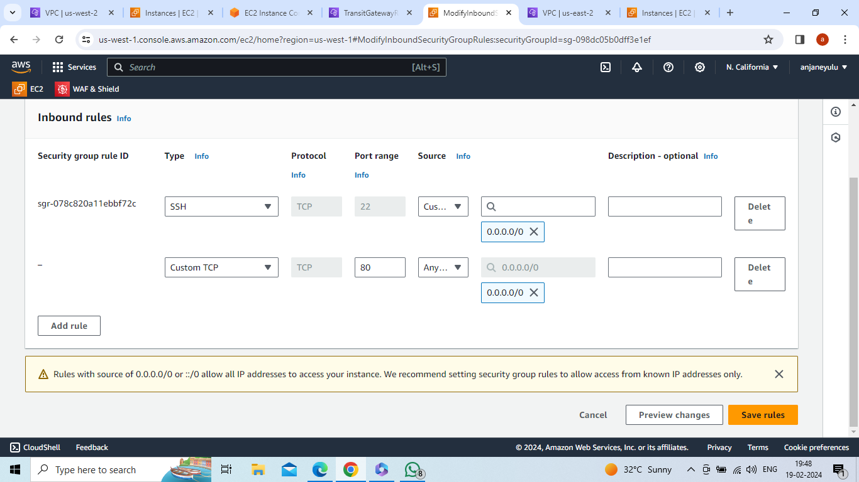

Connect to server in aws (california)

Check index.html data appear in california region what you insert data(index.html) in oregon region

Sudo –i

Curl 10.0.1.132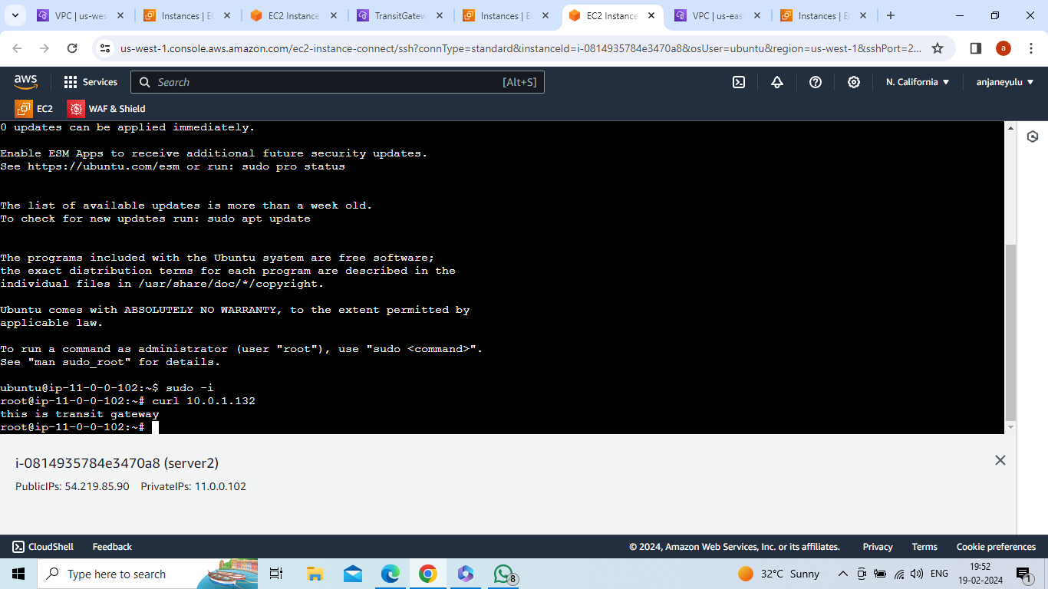

In california region -->create and launch instance : server3-->connect to server

Select : Server3 -->security group -->actions-->edit inbound rules -->add rule-->custom tcp,port range: 80

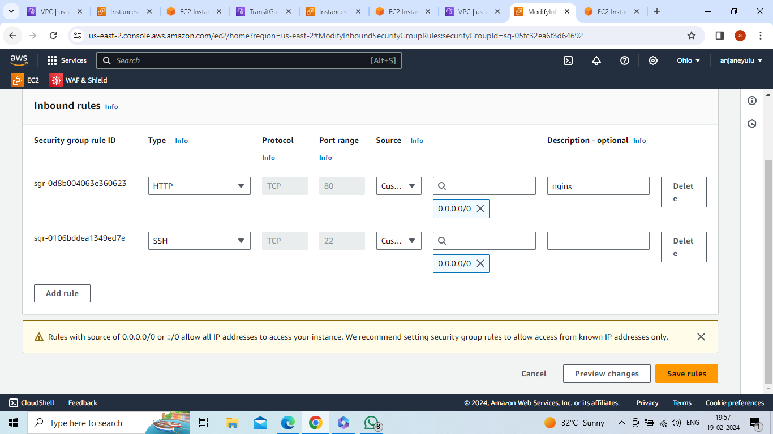

Connect to server in aws(ohio)

Check index.html data appear in ohio region what you insert data(index.html) in oregon region

Sudo –i

Curl 10.0.1.132

